Emax-ABAP- Day 8: 27-03-2026
Cardinality and Association
All ui annotations.
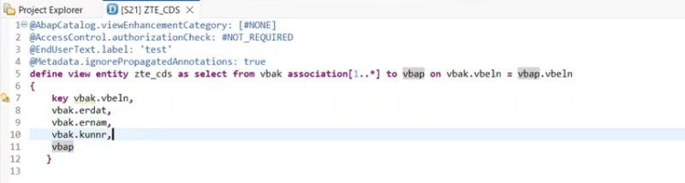

Cardinality : Association
[1..1] - Doesn't mean, you will get the single record in item level.
but how it can decide, has to fetch one or it has to fetch multiple.
Association means it is also a join.

How to check association join operations:
VBAK- header and VBAP - item(target entity)
we are not exposing target entity fields in the selection list, for line item is it created the join or not we will see
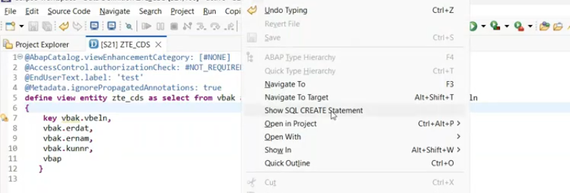
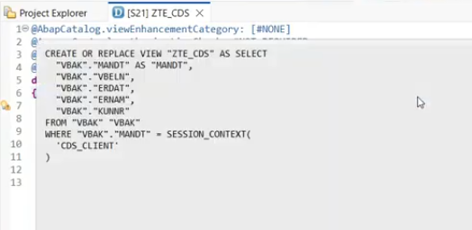
for line item it is not performed any kind of join, it is getting data from header table only.
Header data output:
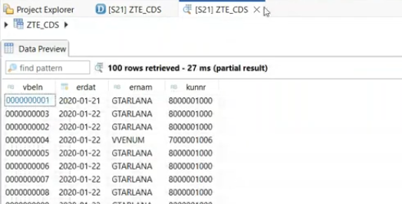
When i expose the association field in the selection list.
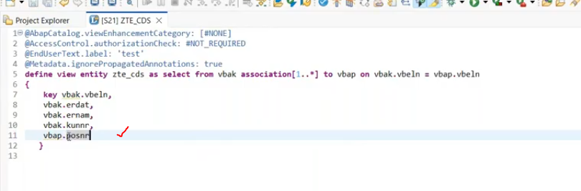
right click on - cds view --> show sql create statement.
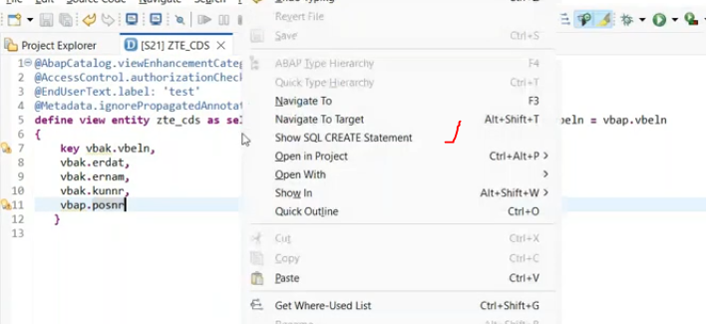
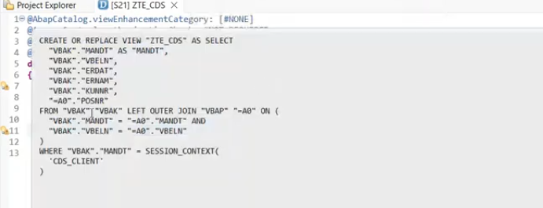
Now join has bound line item also in sql statement.
Association always creates the left outer join.- join happend, when association fields mapped in the selection list. then join will happened.- for [1..*]- join used- left outer join.
if i change the cardinality- [1..1] --> now check the join
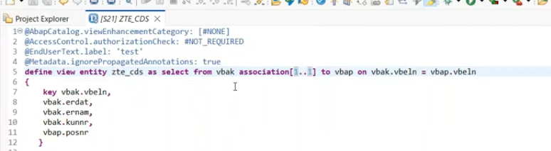
5:40
for [1..1] - left outer many to one join.
[1..1]= does not mean you get only one record.- your associated entity data is influenced the result of the cardinality.
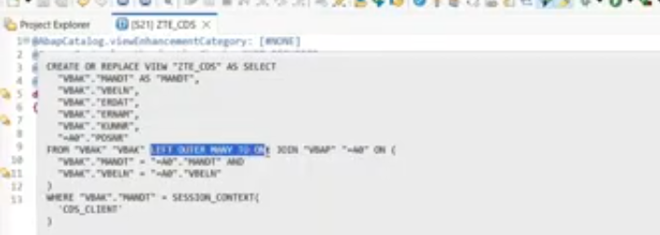
Suppose i want to pick the each of the sales order number in multiple selection also.
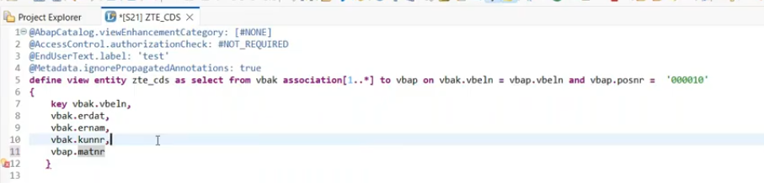 I have to pick whenever the key has multiple items s .but it has to pick the first time.- for so number- 28 has multiple line items, but it has picked only one line item.
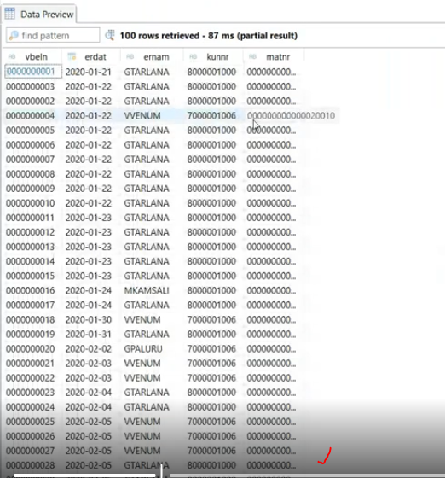
for 28 record, we have two item- we have restricted to get the single line item for each document.
10: 27

Build interactive report using CDS view.
Create SO view.-CDS view entity-
View name-ZVW_SO_ITM- lineitem
Currency amount annotations: @Semantics.amount.currencyCode: 'currency fnamefrom selection list' or 'database name. field name'
Summation on specific field: @Aggregation.default: #SUM
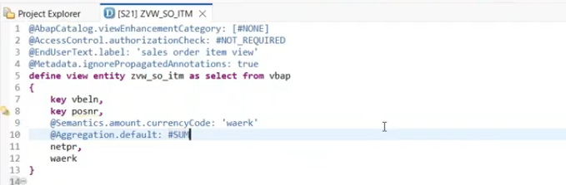
this annotation direct not impact on eclipse we can able to see it when the UI level implementation.
@UI.lineitem- used to visible the column the ui list without manual selection.
for any application in page1- bulk data will be display, if you want to see the single record in detail for the detail- we will be following as object page/next page -@ui.identification:[ { position : 10 }]- this identification will not be recognize by alone, so we have to apply the object page annotation @UI.facet :[ { type : #IDENTIFICATION_REFERENCE }]- this use it in on tope of all the field list of the selection list..
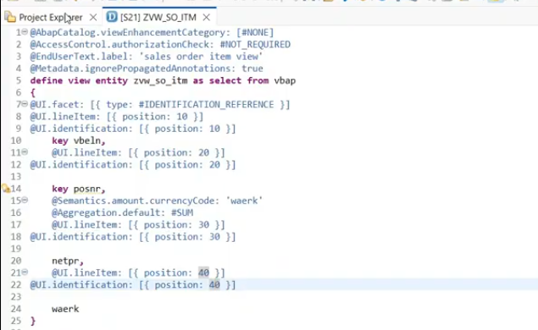
Create CDS view for header so-
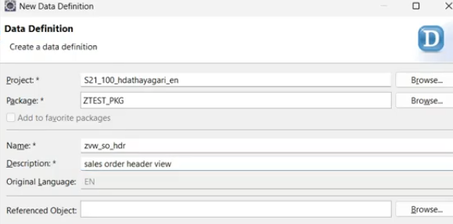
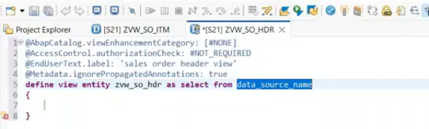
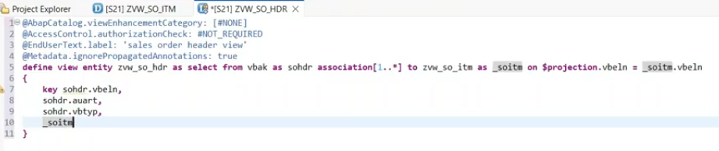
Expose of association in the selection list, this will use it in navigation at ui level, if it is join we can't expose the alias name in the selection list.
while creating the fiori app, for detail page it will ask for navigation entity. for this associations are very useful.
UI screen to display in two tabs- 1. header and 2. item. - for multiple tabs, @UI.facet- type is #COLLECTION
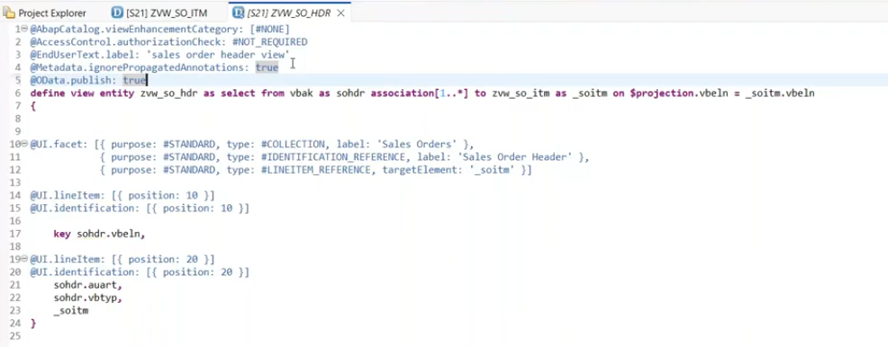
save and activate.
take the odata service and register this.
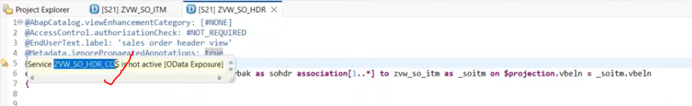
For register : /n/iwfnd/maint_SErvice
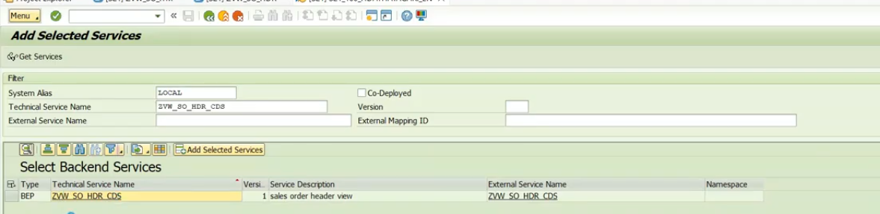
Now service has exposed to outside.

Now we have to create the front application using BAS.
BAS- is one service in BTP
Need BTP trial account.
30:00
Establish the connection between the onpremise and BTP using cloud connector.
in BTP--Sub account--Connectivity --DESTINATIONS- we have to configure those here.

To connect on premise to BTP.
1. Need cloud connector
2. Install that and login with initial password
initial password- ADMINISTRATOR password- manage
BAS- service to open- BAS service has dev space- inside the dev space it will allow to create the Applications.

BAS -Create the Applications
Open the BAS btp(Subscription place)
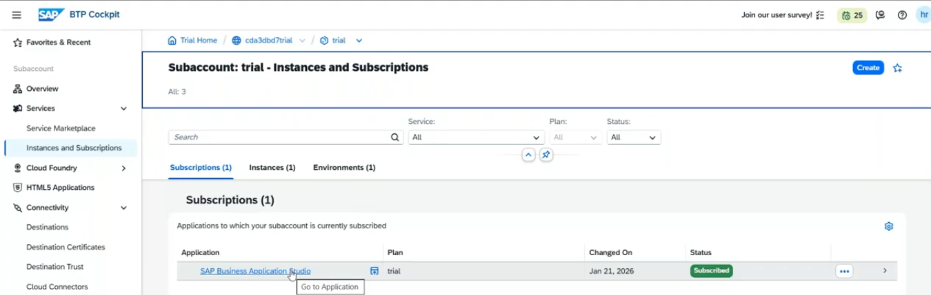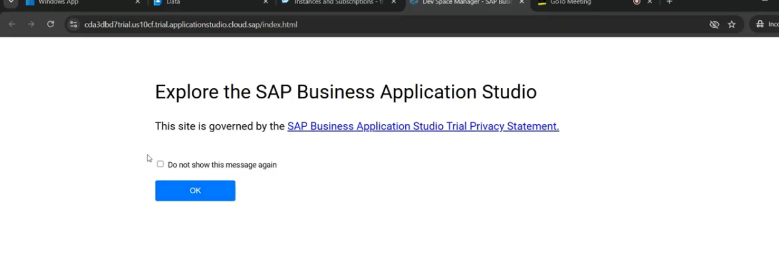
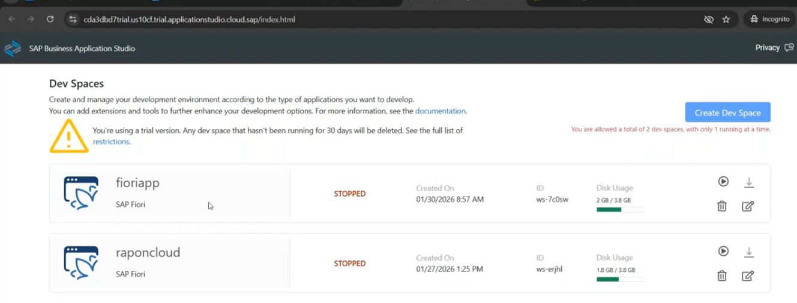
34:00
inside the dev space, we are allowed to create the applications.- you can create maximum 2 dev spaces not more than that. at a time we can run one dev space at a time.
start the dev space:
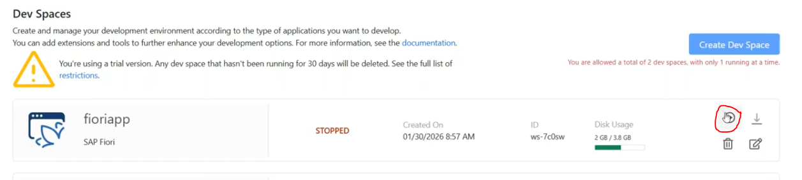
status - starting to runing means - you will allowed to use.
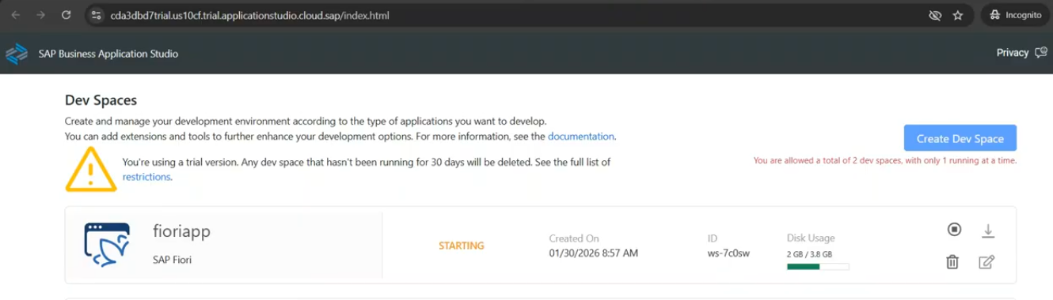
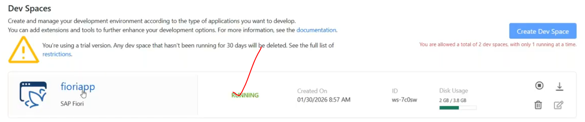
once state has changed to running- now we can develop the applications.
For fiori applications:
we have multiple fiori applications which we wanted to build:
1. free style applications :
- it creates the empty page. developer has to return down the logic.- developer is the min role here.
2. list report applications
- something related to templates, here you have to bind your entities - it will automatically creates the applications. as a developer you don't do anything with the code perspective.- developer not required to generate the applications.
Open the BAS from dev space:
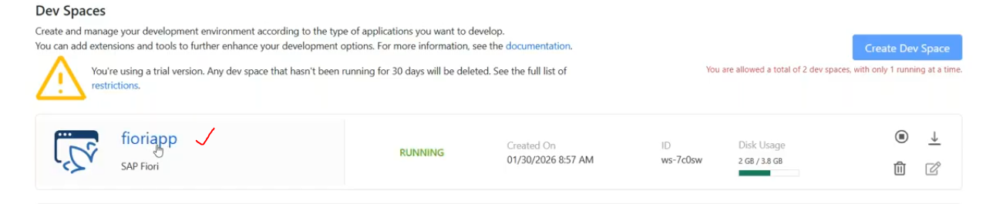
click on Fioriapp name, it will open the BAS.
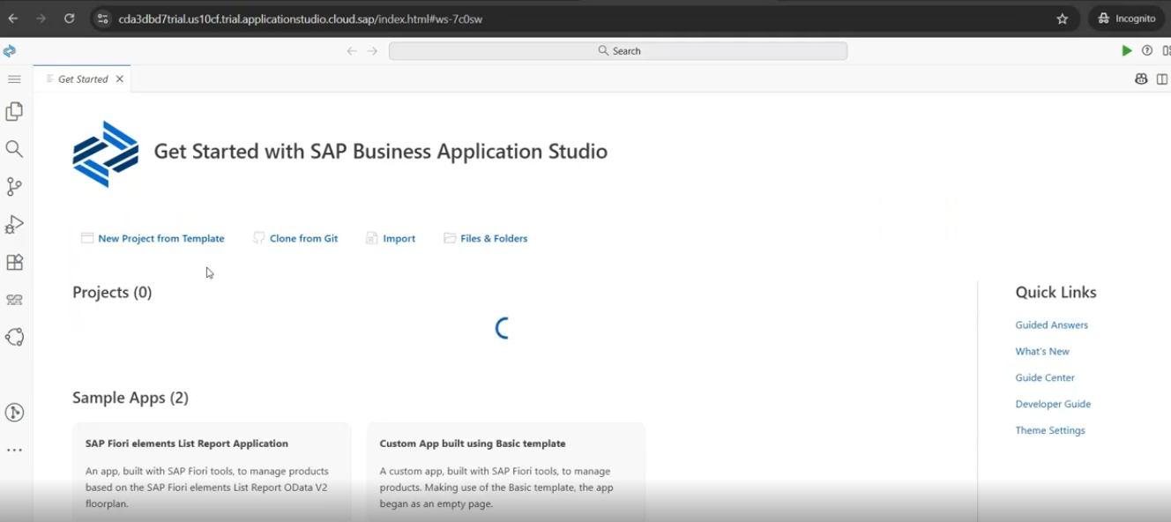
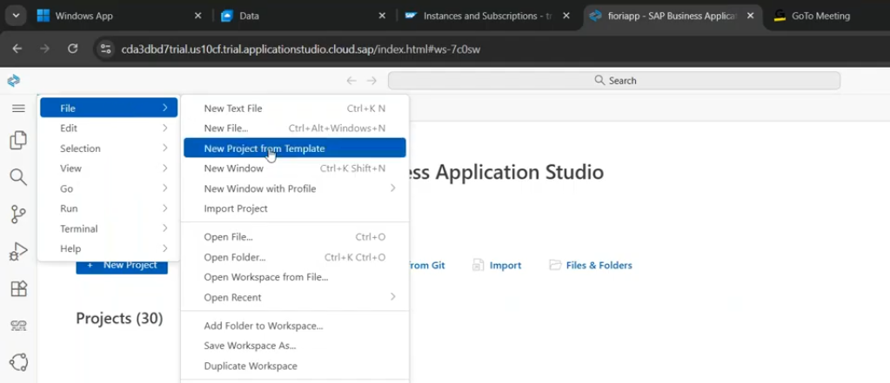
39
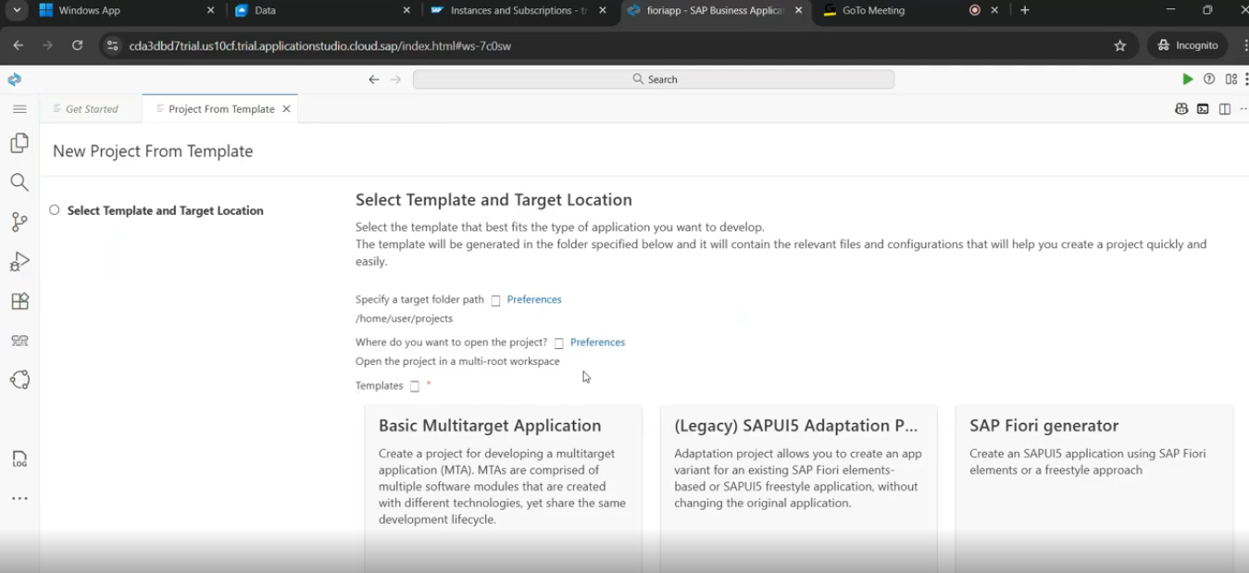
select the SAP fiori generator.
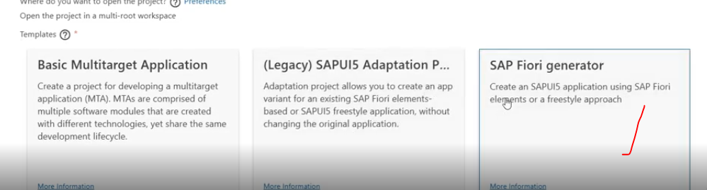
Fiori generator- only for fiori elements or free style apps only.
click on start button.
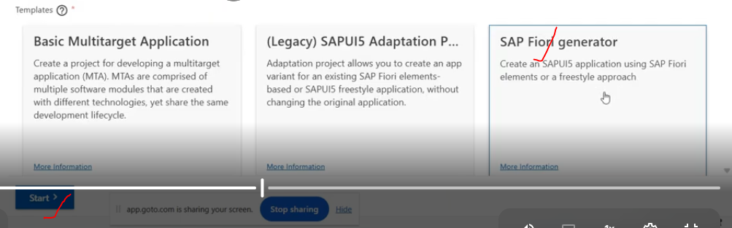
Next step is template selection:
Template selection: What type of application to choose.
either - basic/custom page/list report page
basic- free style apps
list report- fiori elements app.
- initial screen called as list report and next screen called as object page.
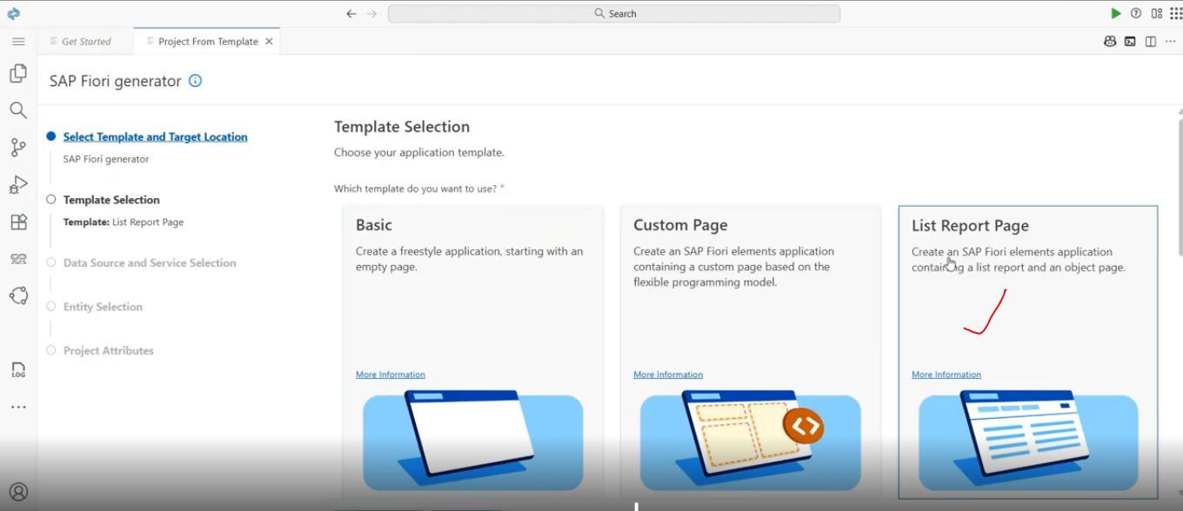
Select the list report page template.
Goto Data source and service selections
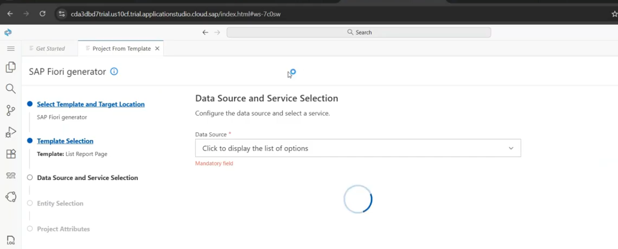
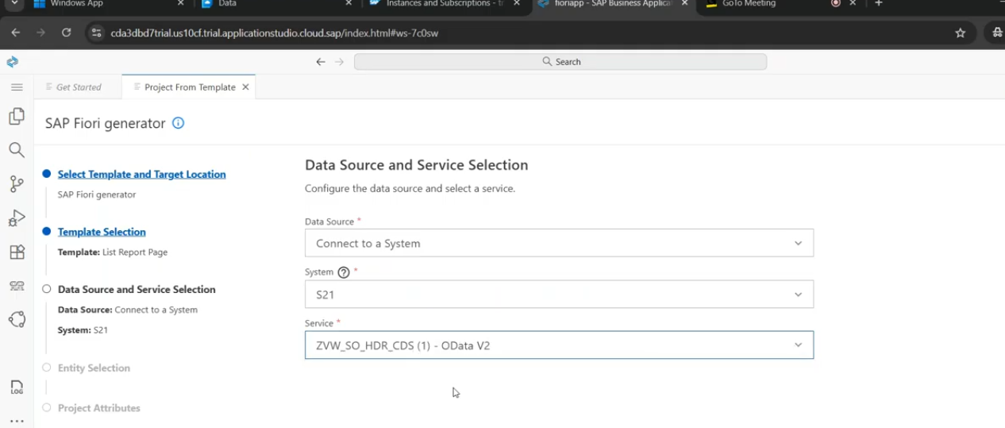
main entity- initial report
Navigtion entity: Detail page( real usage of association )
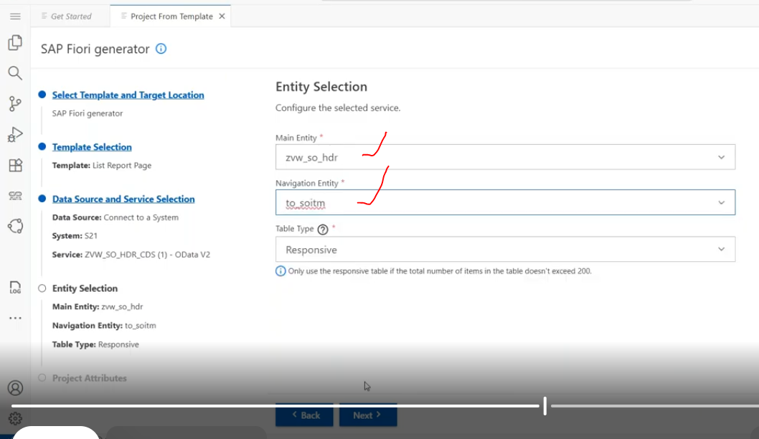
module name(Application Name):
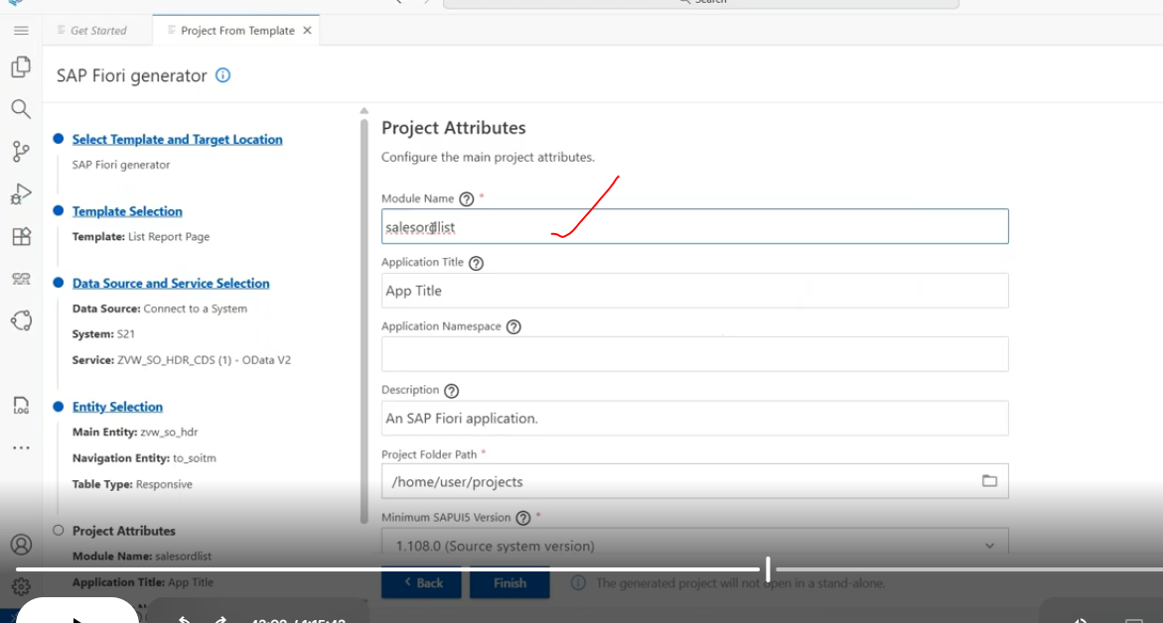
Click on finish
once click on finish, it will install the some dependencies and wait for some time.
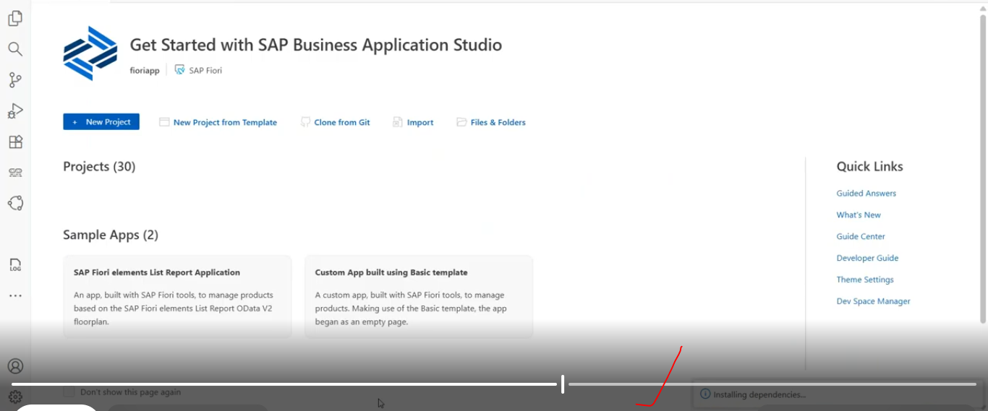
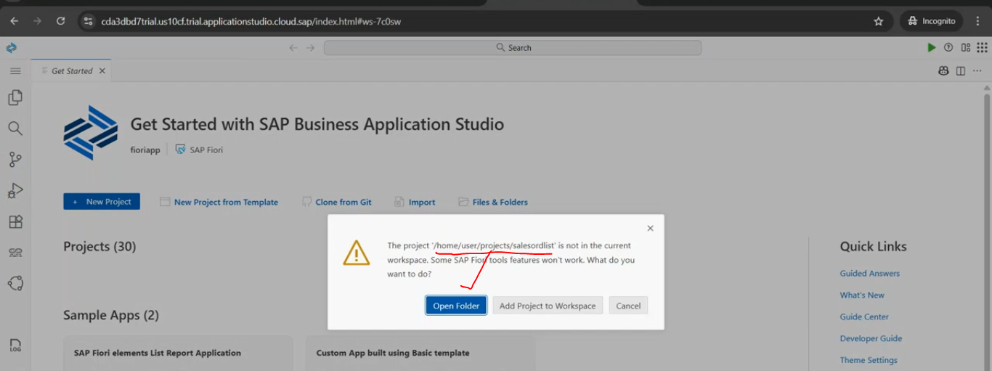
click on open folder.
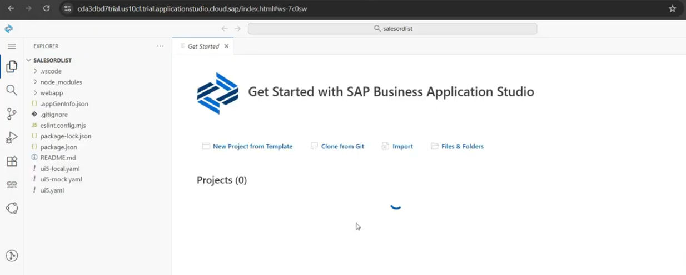
salesorderlist application has been opened.
in fiori- every application will be having the webapp folder.
inside webapp folder- we have the local service are there, if you check that metadata.xml inside the local services.
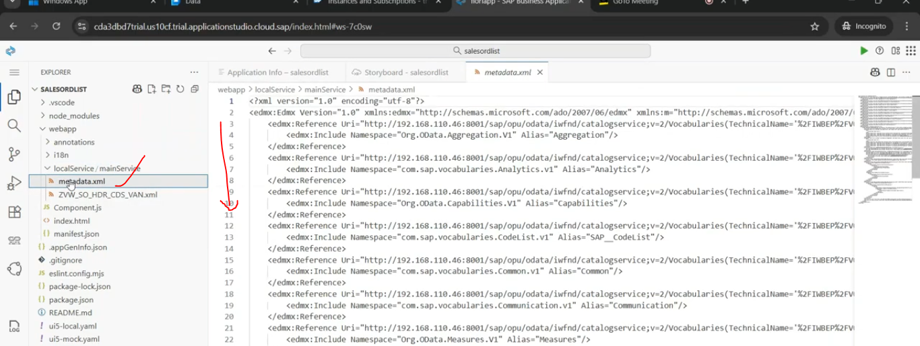
here you can check the odata properties and type of it here only, not required to open the backend system.
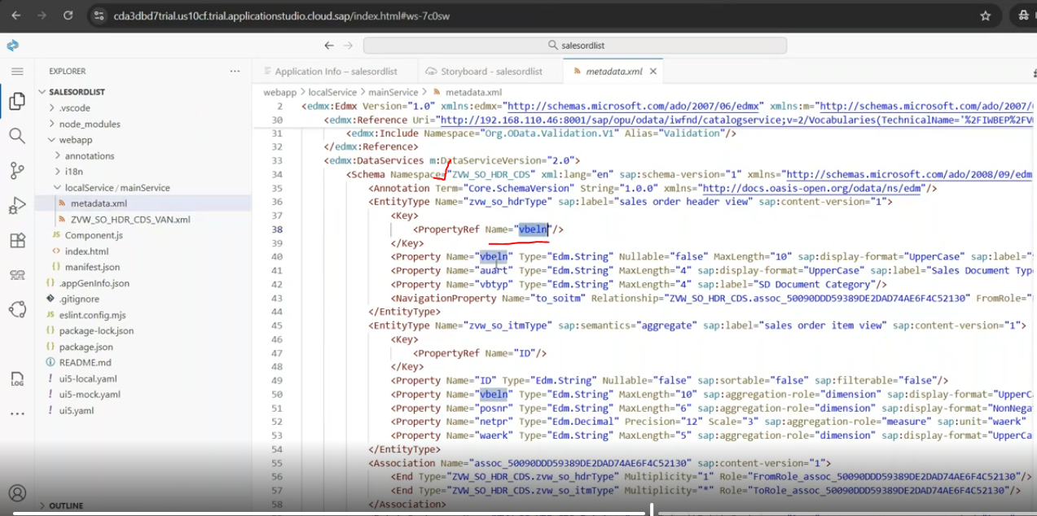
backend metadata all replicated into here..
check the preview applications:
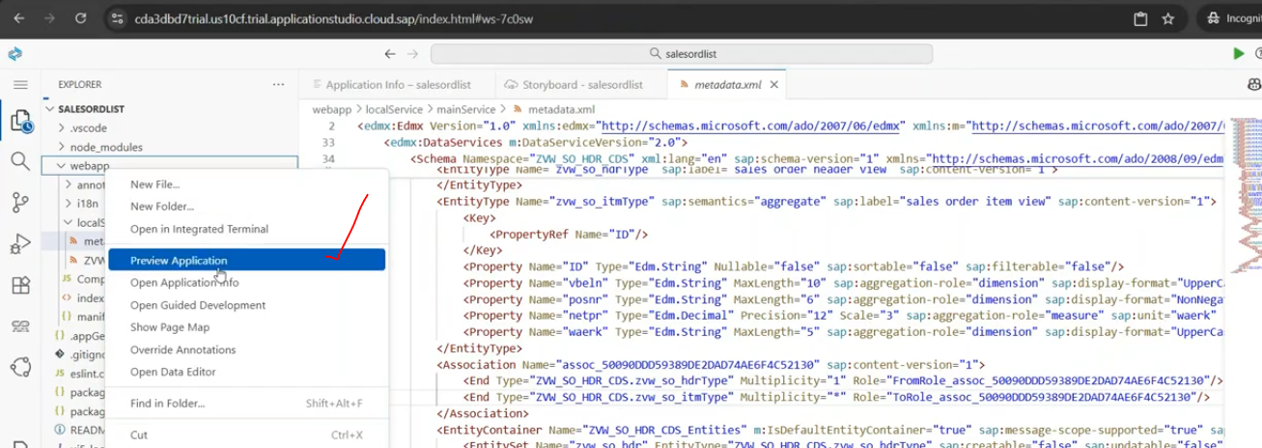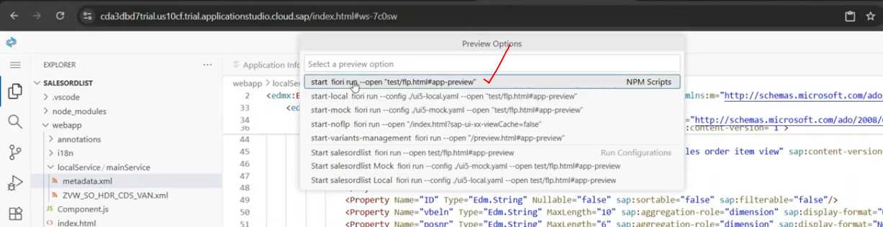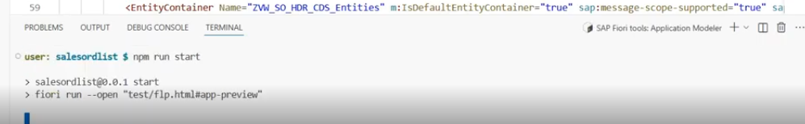
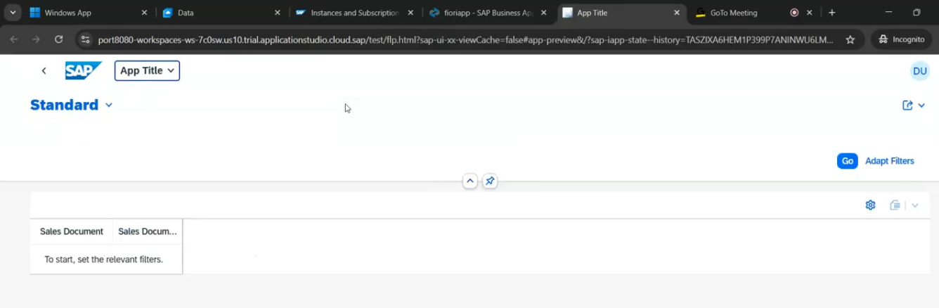
@UI.lineitem --> provides for heading of the table in report/list(field catalog)
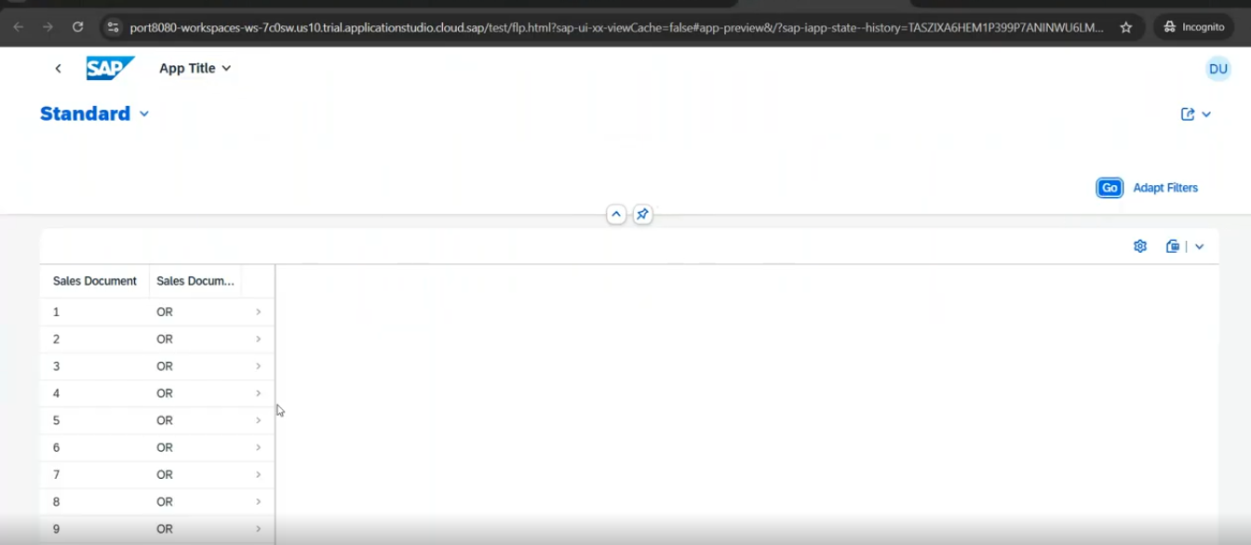
for vbtyp(SD Document Category) -just click on the settings- select the vbtyp
46:00
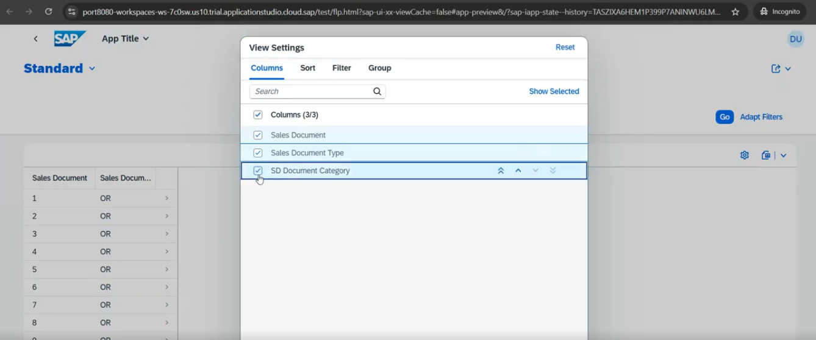
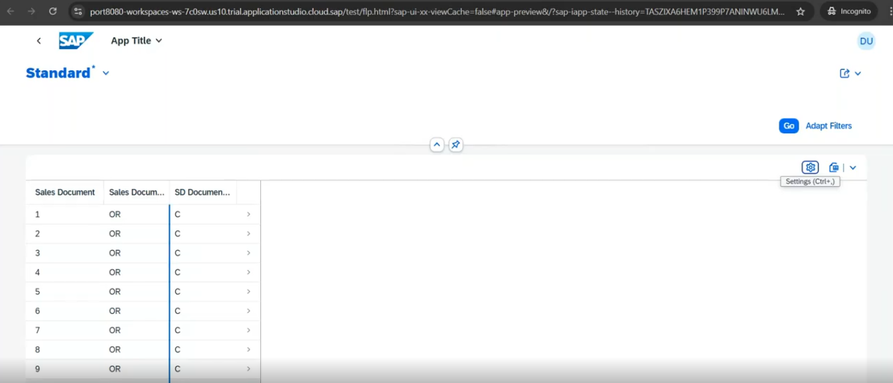
if you click on header record, then item entity will call.- for header-SO number -28 we have multiple items right?- so click on header-28 - so number.
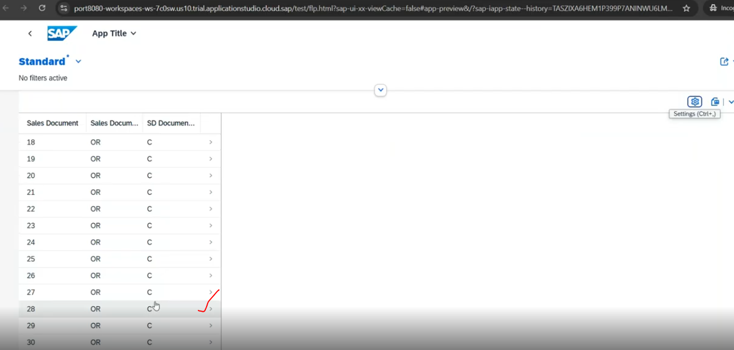
Object page( for item list)
but we defined two tabs- but it is coming into the single tab- why?- you missed the lable for line item.
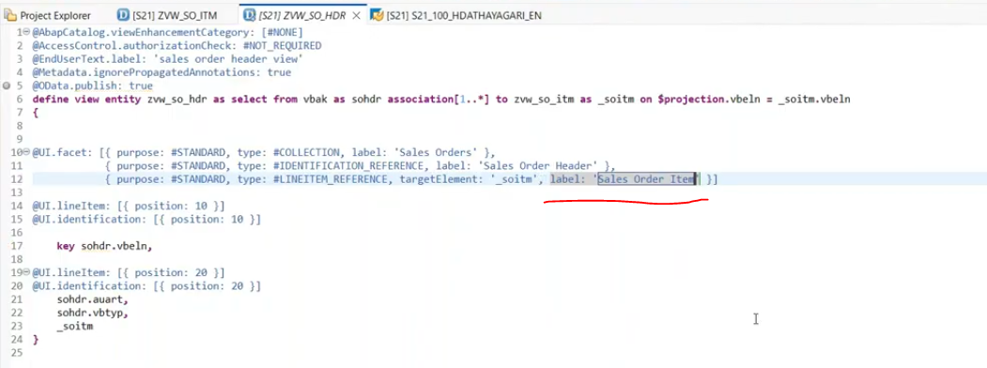
refresh the page at browser.
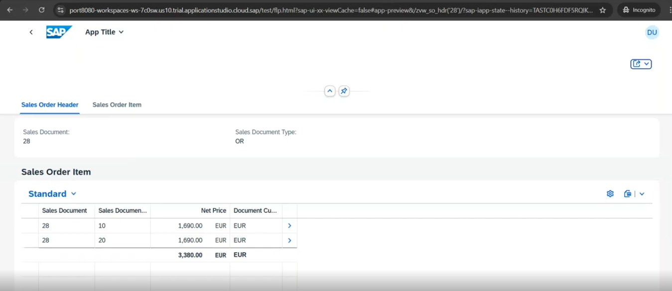
Now we go the two tabs- one is sales order header and second one is sales order item.
this is the interactive alv fiori app.
Q. if i want any column data should be in the bold/high lighted.?
On top of view name.
Annotation for bold: @ObjectModel.semanticKey: [ fieldname' ]
@ObjectModel.semanticKey: [ 'auart' ]
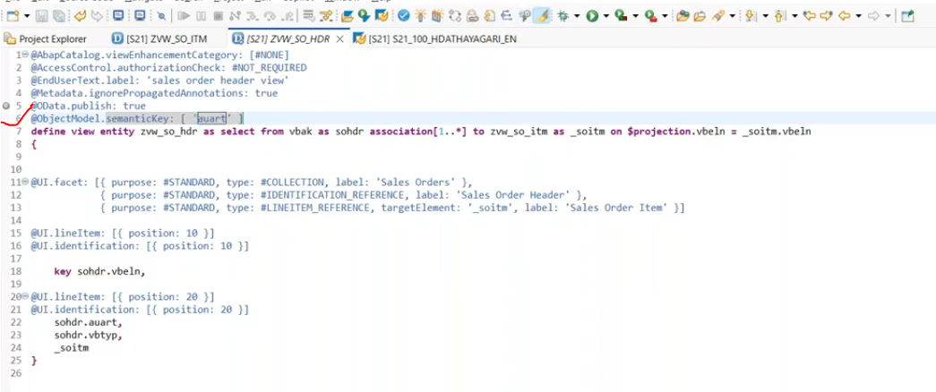
let me refresh the page.
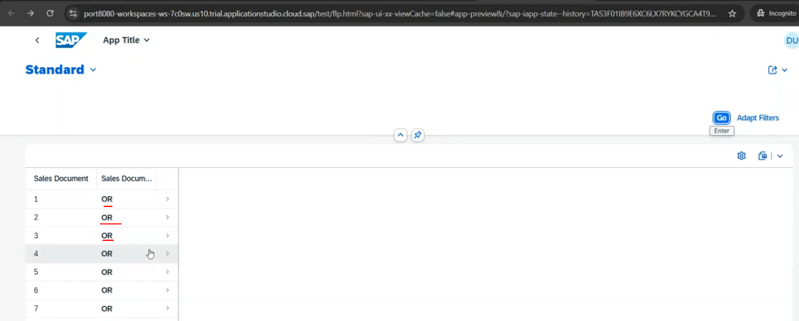
Q- Apply the filter in header section, then i can filter out my data?
on top of field name:
Annotation: @UI.selectionField: [ {position: 10} ]
sohdr.auart
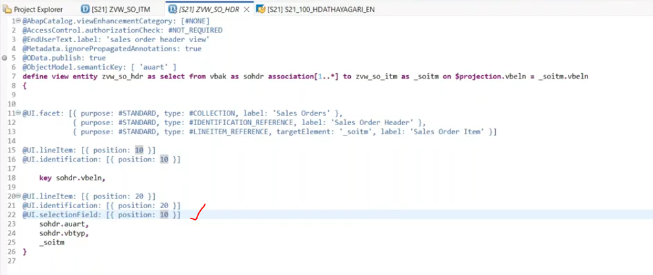
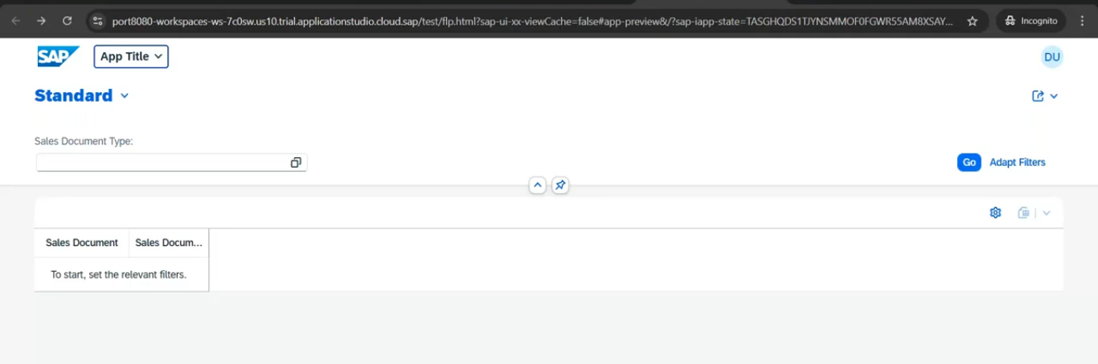
Filter: Document type data will be added.
Filter with KE
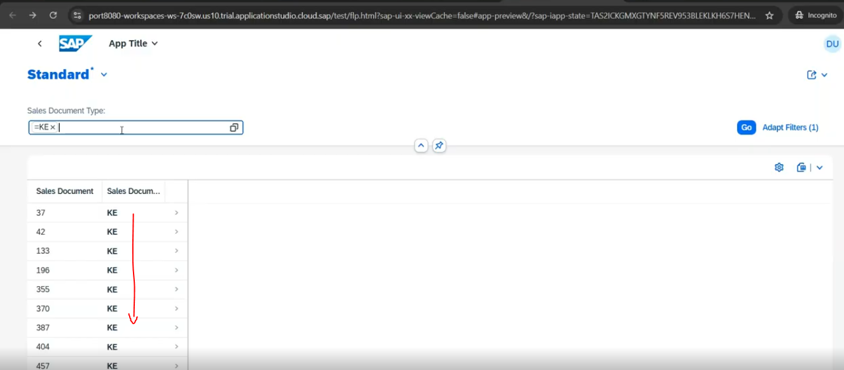
Q- if you want to apply the title and along with the count? How many records in my application
on top of the view:
@UI.headerInfo: { typeName: 'SO List', typeNamePlural: 'SO lists' }
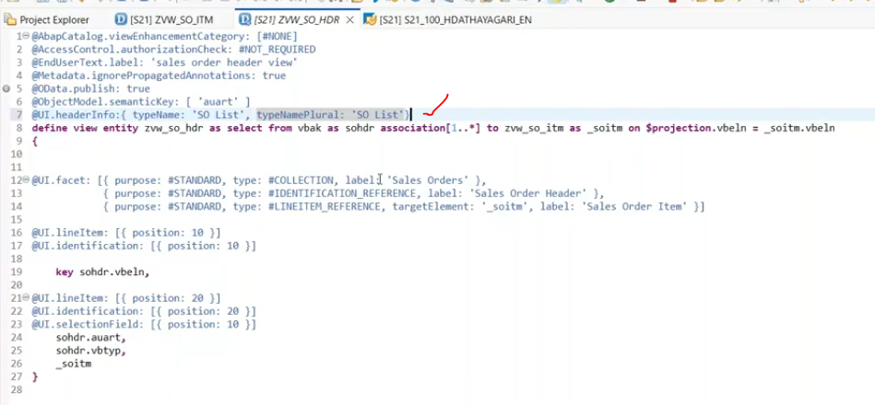
Now it is display the count of how many number of records in your application.
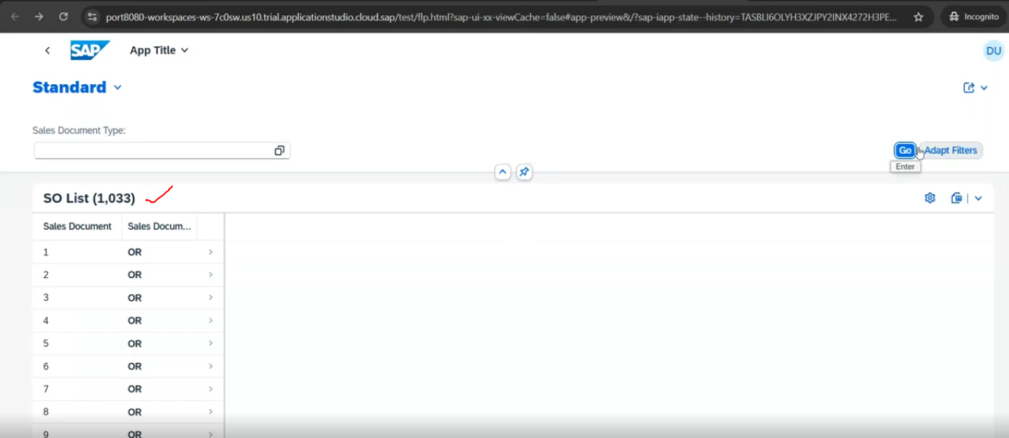
After the filter- How many number of records do you have?
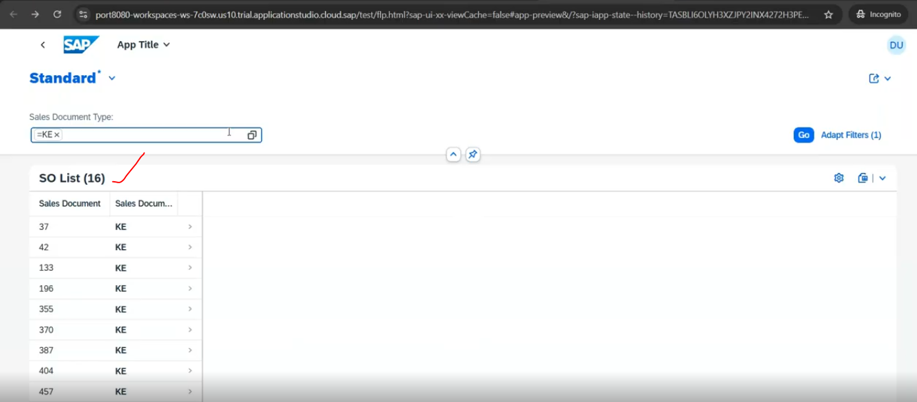
Q: filter should be mandatory?
Annotation: @Consumption.filter.mandatory: true
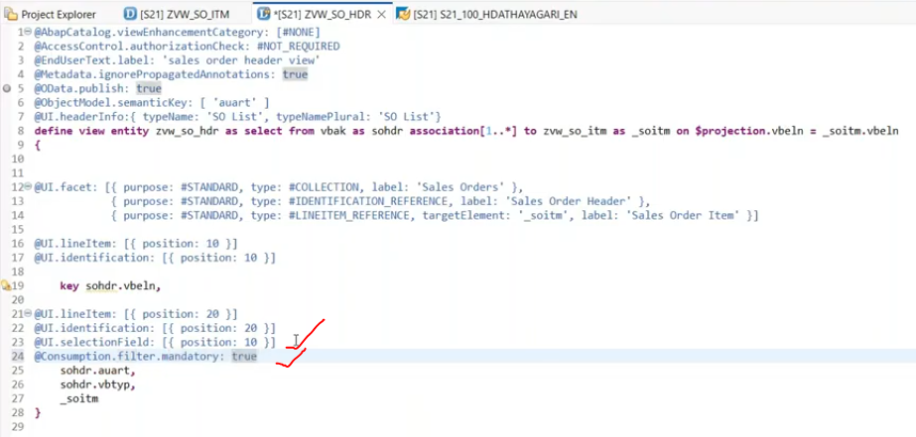
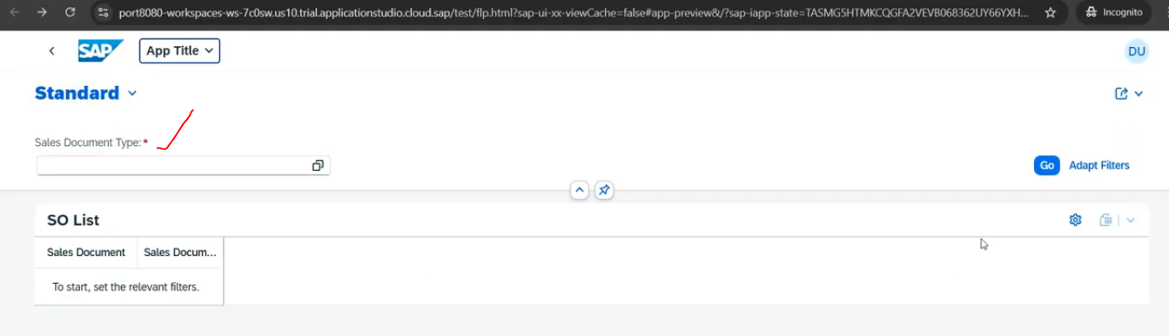
*- means mandatory
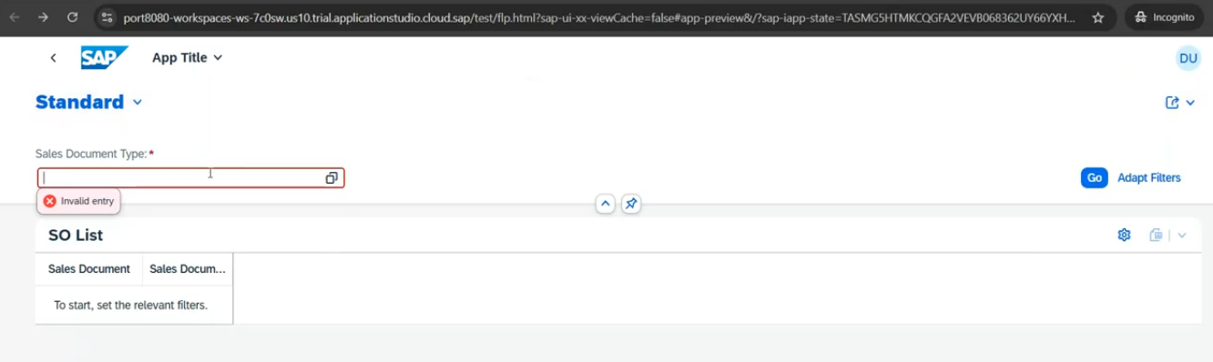
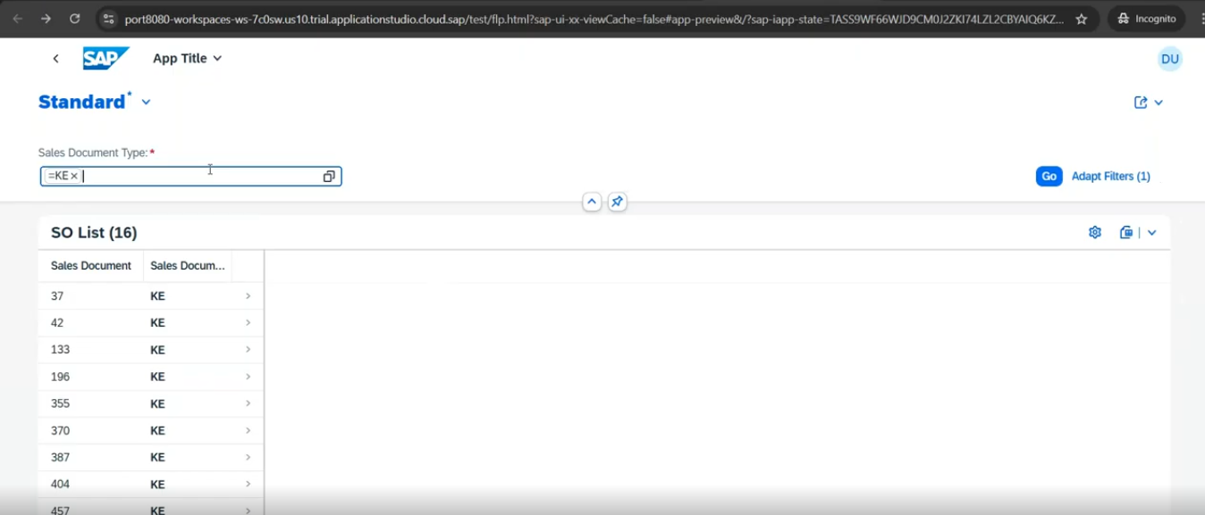
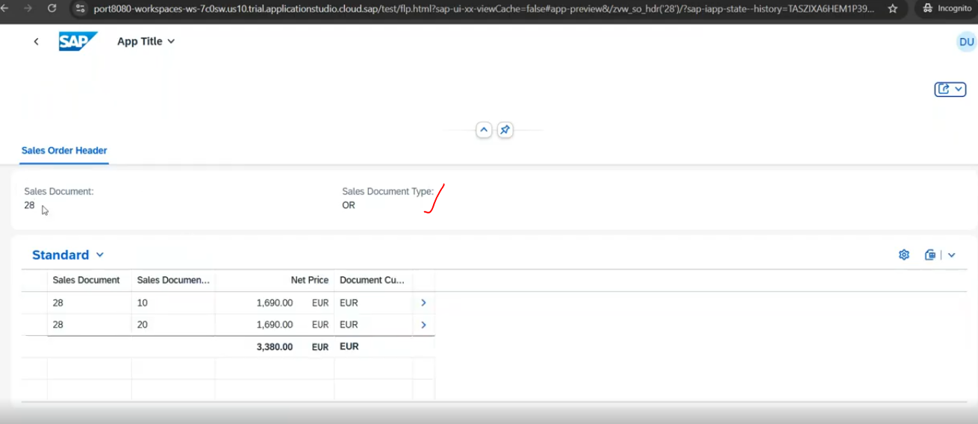
Q- Default filter at the time of application loaded?
@Consumption.filter.defaultValue: 'KE'.
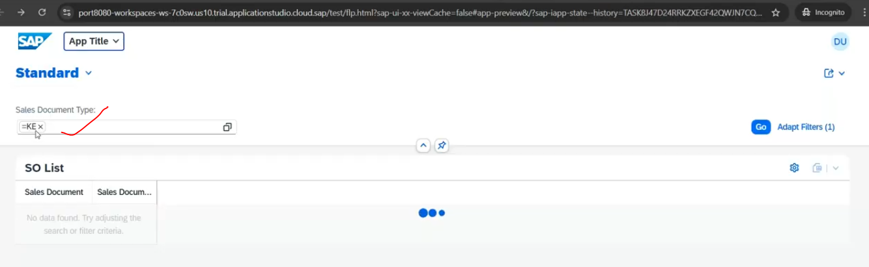
KE- is automatically added..
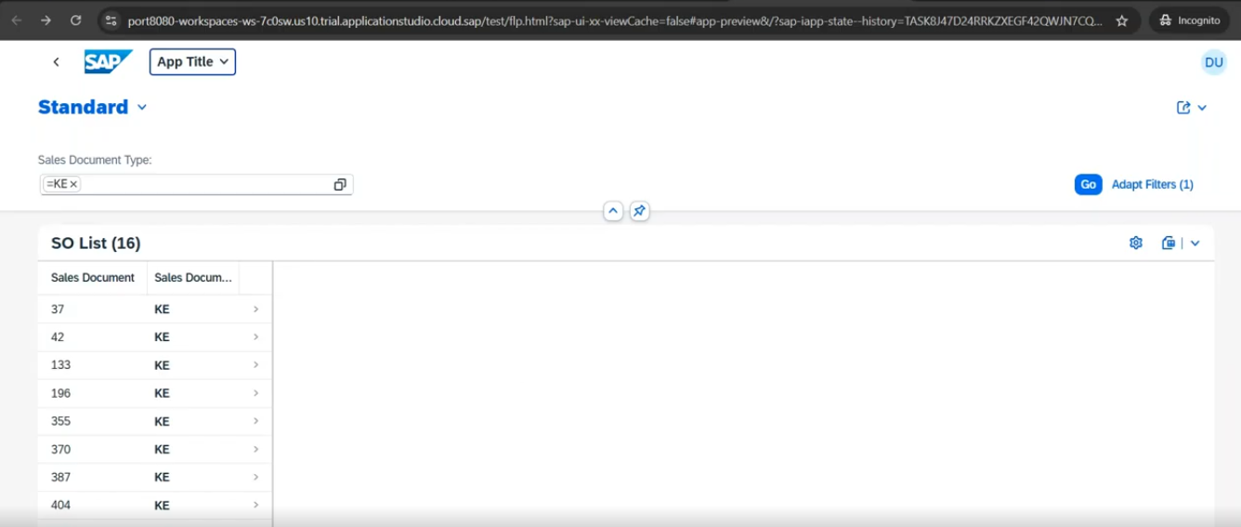
Q- value help( f4 help) - at the time of F4 we need to populate some data.
For value help- we need separate entity required.
Create new data definition: ZVH_SOHDR.
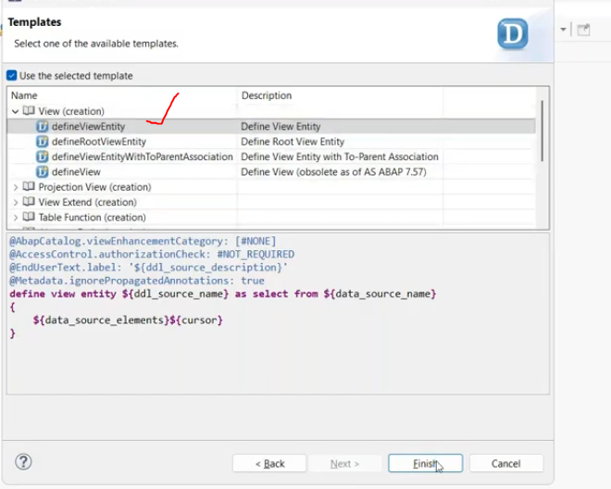
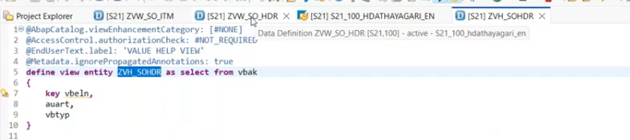
this will consume the value help for data source.
Data source for f4 help- ZVH_SOHDR.
Annotation: @COnsumption.vlueHelpDefinition:[ { entity: { name: 'ZVH_SOHDR, element :'auart' }}]
name- entity type
element: which fields do you want to apply the value help.
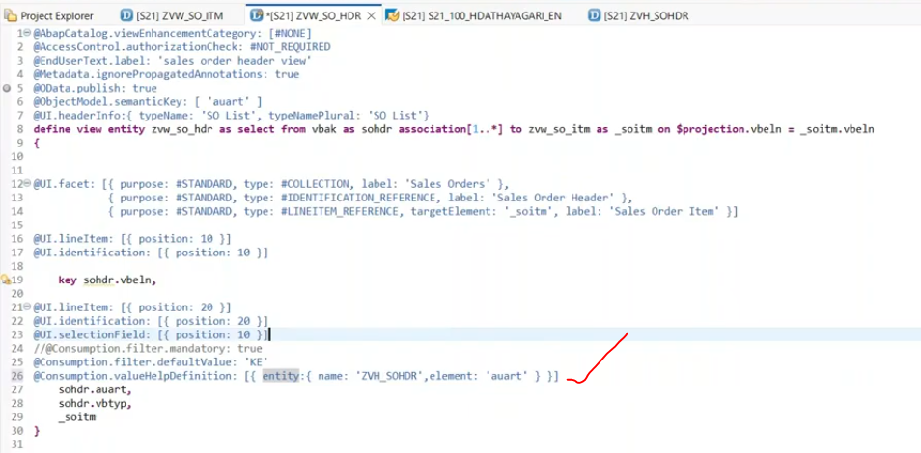
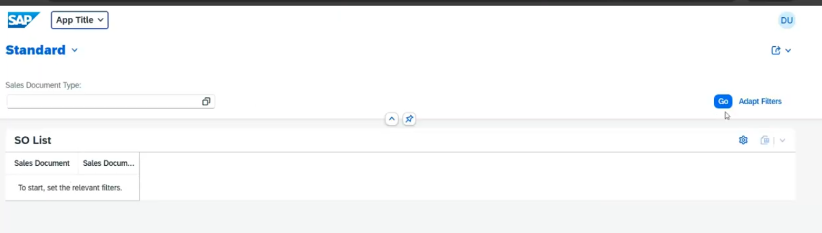
click on go
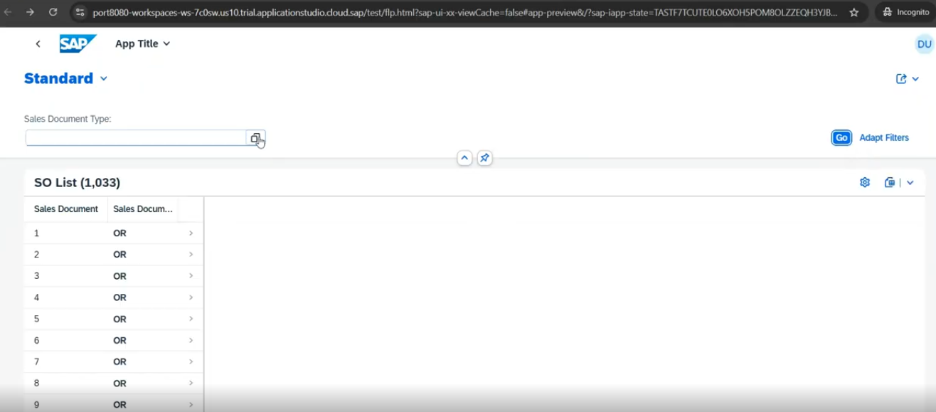
Now click on F4 help on sales document type.
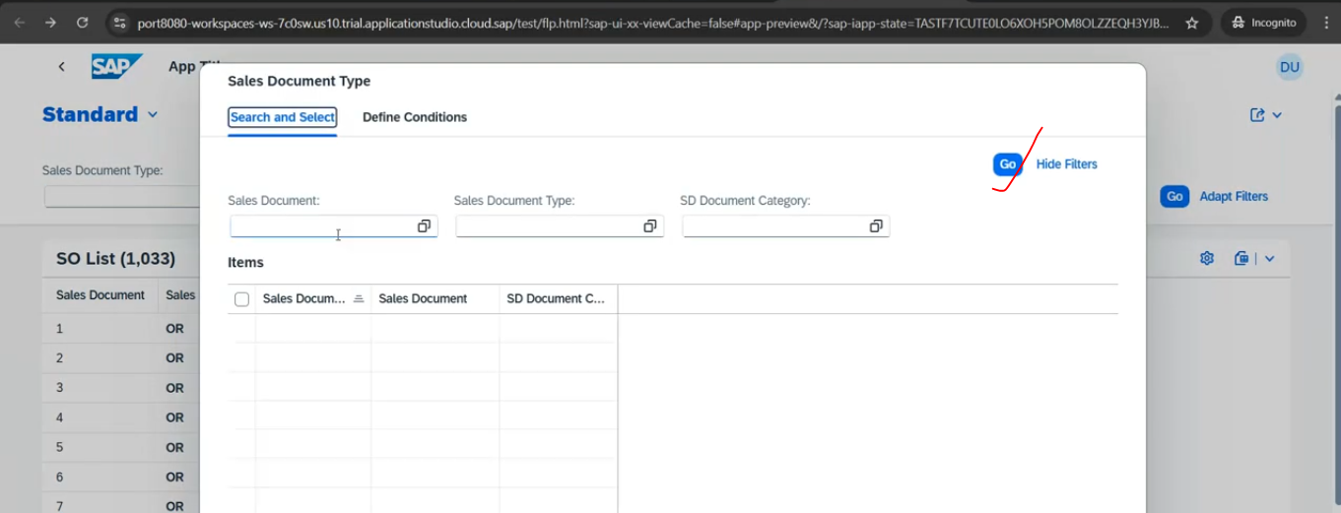
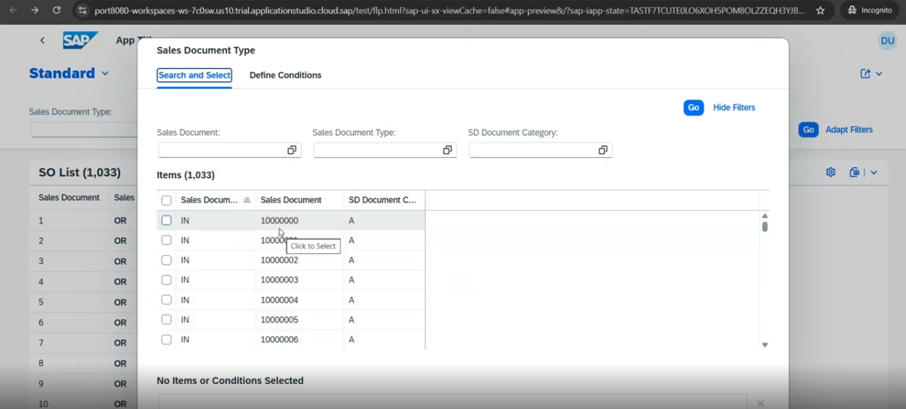
Select the record and click on go
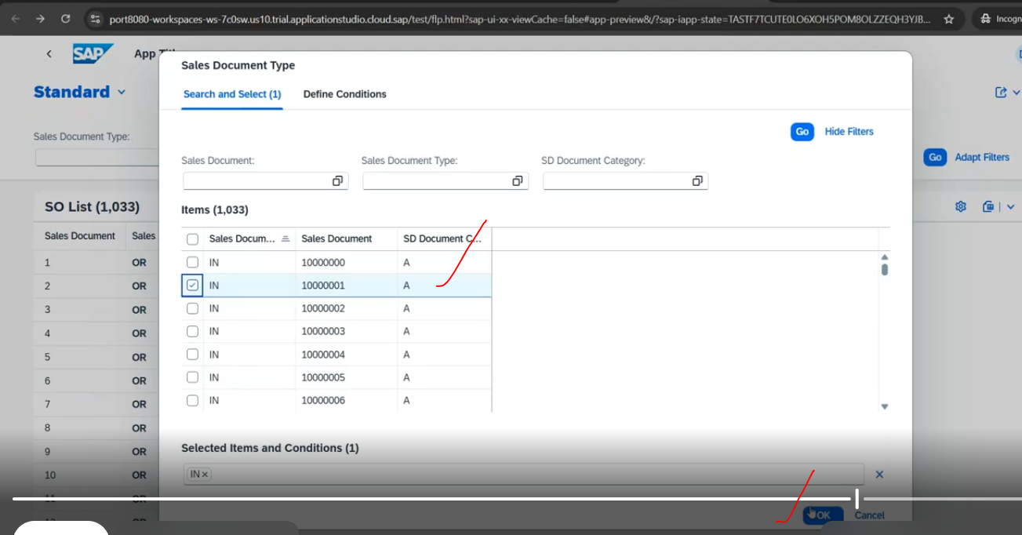
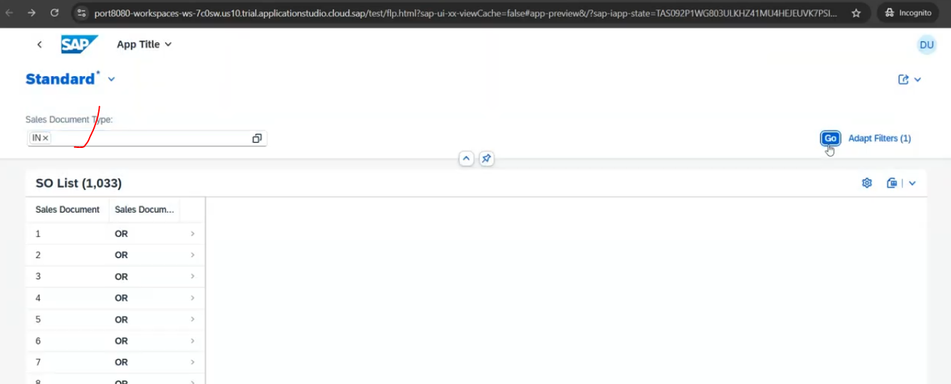
click on go
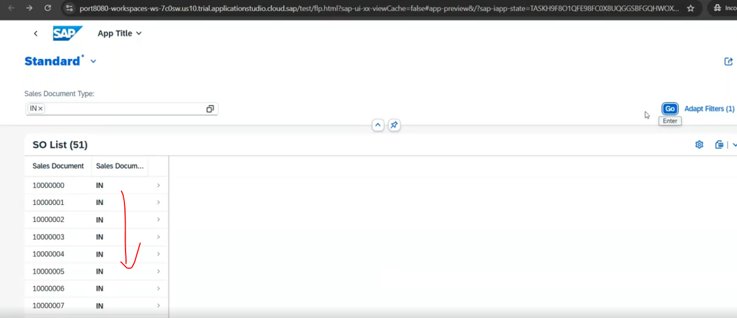
Q- convert value help into drop down( list box ).
for value help, where the data is coming for that you have apply annotation- their.
Annotation: @ObjectModel;.resultSet.sizeCategory: #XS - XS means extra small.
if apply this annotation - your value help will be drop down list.
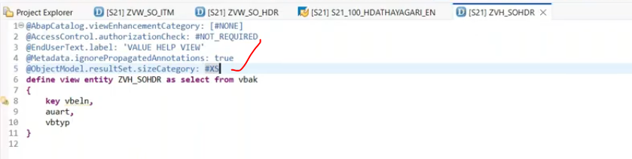

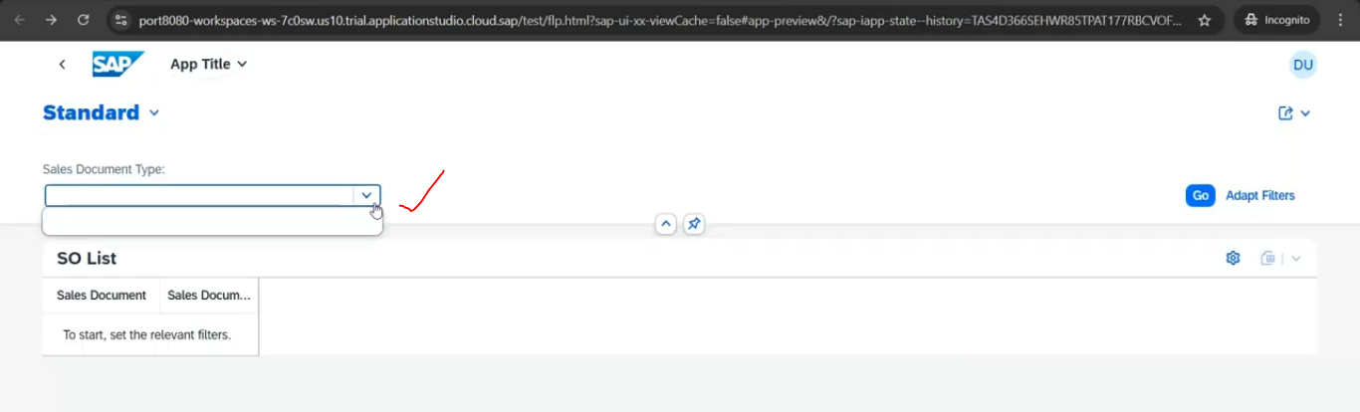
Now you can see the drop down.
click on the go.
